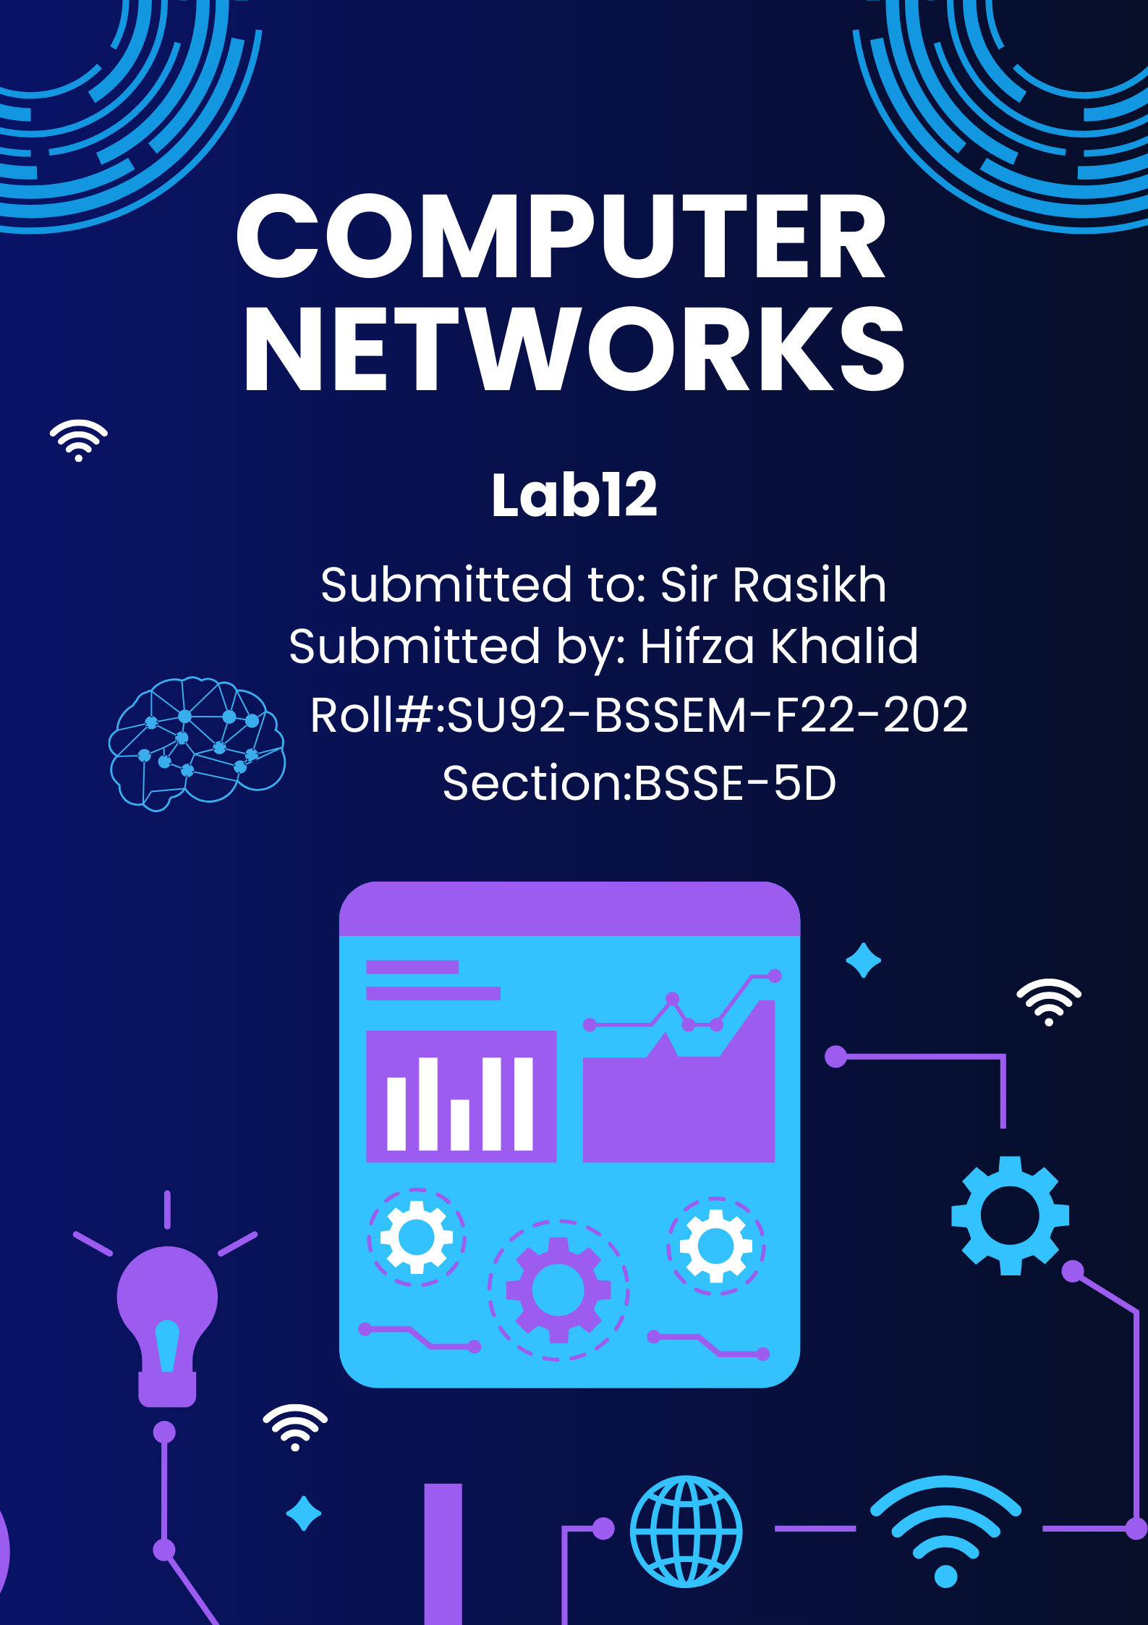

# **Lab 12**

## Configure VLAN & Inter-VLAN Routing

**Web-Link:**

https://computernetworking747640215.wordpress.com/2018/07/05/vlanconfiguration-on-a-cisco-switch-in-packet-tracer/

# Lab 12 - Task

## Task 1;

**What is difference between “VLAN & Inter-VLAN Routing”, explain with**

**Example (draw structure in cisco)**

* **VLAN (Virtual Local Area Network):**
* **Definition**: A VLAN is a logical grouping of devices within a network, segmented into separate broadcast domains. VLANs are used to improve network efficiency, enhance security, and organize devices logically, regardless of their physical location.
* **Purpose**: To isolate traffic and create separate networks within the same physical switch or infrastructure.
* **Communication**: Devices within the same VLAN can communicate directly, but devices in different VLANs cannot communicate without additional configuration.

**Example**:  
A company has three departments: HR, Sales, and IT. VLAN 10 is assigned to HR, VLAN 20 to Sales, and VLAN 30 to IT. Devices in VLAN 10 can communicate only with each other but not with devices in VLAN 20 or VLAN 30.

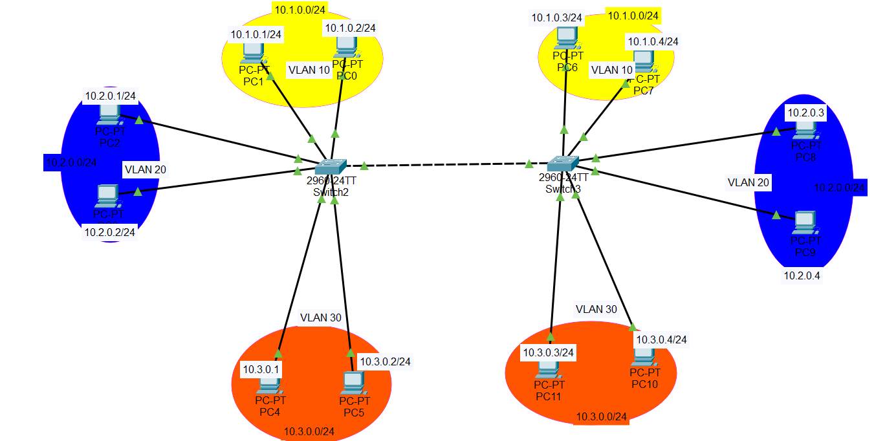

* **Inter-VLAN Routing:**
* **Definition**: Inter-VLAN Routing is the process of enabling communication between devices in different VLANs. It is achieved by routing traffic between VLANs using a Layer 3 device (like a router or a Layer 3 switch).
* **Purpose**: To allow devices in separate VLANs to exchange data while maintaining logical isolation for other purposes like security or traffic management.
* **Communication**: Enables devices in different VLANs to communicate with each other by routing traffic between them.

**Example**:  
Continuing with the above example, if an HR computer in VLAN 10 needs to share data with a Sales computer in VLAN 20, Inter-VLAN Routing is required. A Layer 3 switch or a router can be configured to route traffic between VLAN 10 and VLAN 20.

